Mise-en-Scène

What is Mise-en-Scène?
- A French term meaning what is put into a scene or frame
- Visual information in front of the camera
- Communicates essential information to the audience
- made up of various elements

Elements of Mise-en-Scène?
- Settings & Props
- Costume, Hair & Make Up
- Facial Expressions & Body Language
- Lighting and Colour
- Positioning of characters/objects within the frame

The following research activities will help familiarise you with the concept and develop image interpretational and analytical skills.

Consider the questions below to provide a framework for your blog and a brief summary of what you have learnt.

Research Activity 1

Can you describe how the elements of Mise-en-Scène in the following scene?

Watch the following scene

- Snow White (Disney Studios,1937)
- https://www.youtube.com/watch?v=cB7O_JIxGuY

- Settings & Props
It is set in a dwarf cottage, which creates a sense of warmth, cosiness, and handmade charm. Props such as oversized wooden furniture, a soup pot, carved stools, and rustic tools showcase domestic labor and inviting simplicity.
- Costume, Hair & Make Up
Snow White is wearing a puff-sleeved blue dress, a yellow skirt, a red head bow, and has neat hair. Her makeup is soft with rosy cheeks.
- Facial Expressions & Body Language
She moves gracefully yet energetically, leaning forward when in the house to express curiosity and kindness. Her open gestures make her appear nurturing and socially warm.
- Lighting and Color
The colour plate consists of earthy browns, soft shadows, and vibrant primaries(blue, yellow, red). The lighting is high key and soft.
- Positioning of characters/objects within the frame
She is slightly off-centre, surrounded by the cottage and animals. Objects and animals encircle her, making her the centre of focus, and the composition supports her role as a caretaker.
- What role does the shot choice (Cinematography) play in the scene?
It favours a medium-wide view that displays the environment, allowing mise en scene to carry narrative meaning. The wide comp ensures the audience absorbs spatial storytelling.

Research Activity 2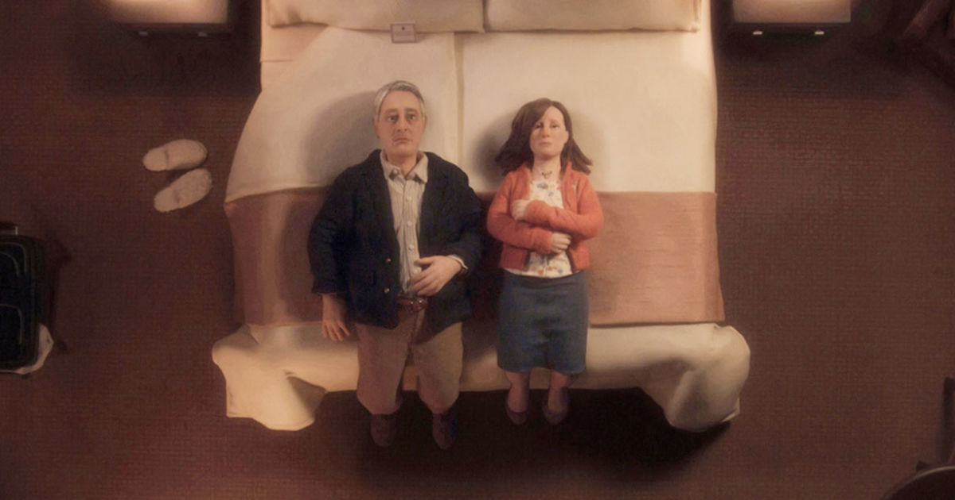
Anomalisa. Charlie Kaufman 2016
Can you describe the mise-en-scene in this picture? How are the characters placed in the frame?

This image employs a minimalist, muted realist design, a beige-toned environment, low-saturation props, and a puppet figure with an inexpressive face. This monotonous look conveys numbness and existential repletion.

Characters are placed symmetrically, facing up with physical stillness. The rigid blocking suggests emotional distance. The frame composition reflects inner turmoil despite external order.

Research Activity 3

Watch this scene from Rebecca.
https://www.youtube.com/watch?v=h23zAV2Wnps
(36mins into the film)

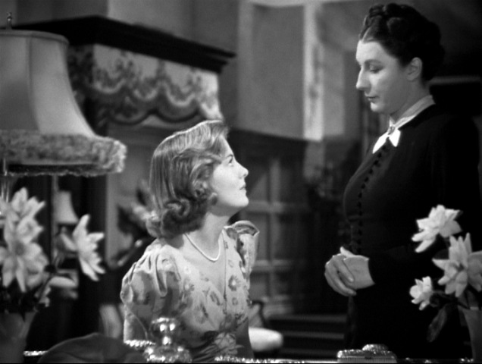
Rebecca (Hitchcock.1940)

Can you describe the relationship between the characters?

How do we know what the relationship is?
Can you describe how the mise-en-scene works together to tell us what the relationship is?

Their relationship is hierarchical, emotionally restrained, and socially formal. He holds power through age inheritance
How do we know the relationship
- Set scale
- Blocking
- Lighting

All elements collaborate to externalise internal tension, dark wood interior, deep shadows, and oppressive spatial depth reflect a relationship clouded by memory, grief, and unsaid emotion.
High Key Lighting
Low Key Lighting
Natural Lighting
High Angle Shot
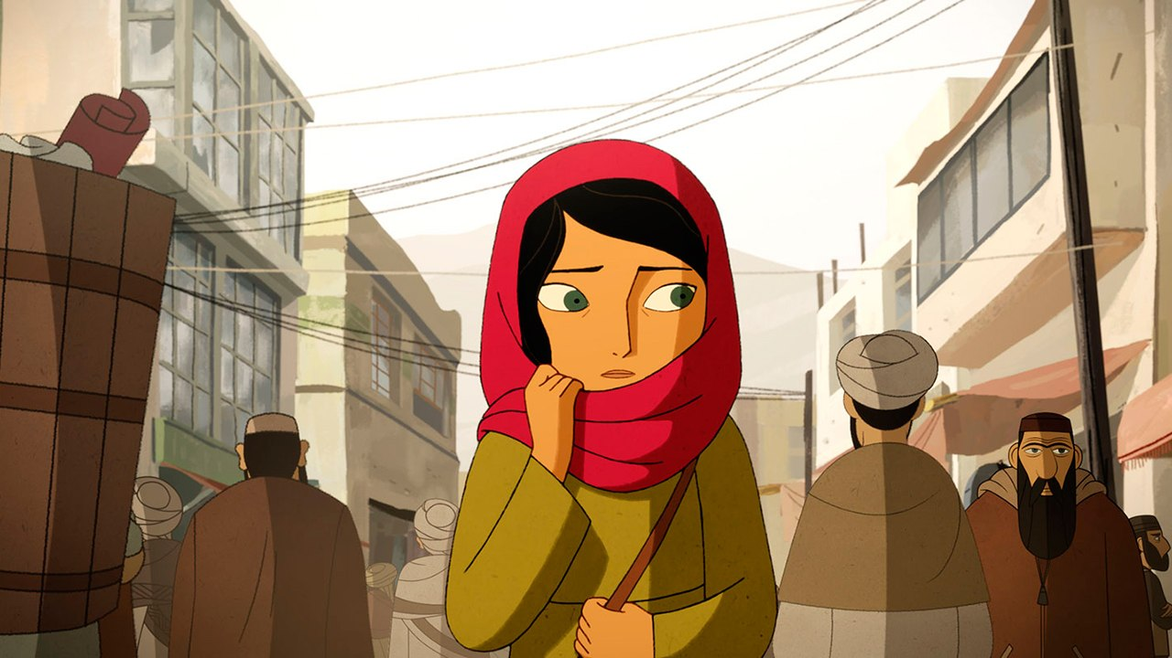
Low Angle Shot
Can you describe the mise-en-scene in this picture?-It emphasizes emotional state and communists’ power through environment costumes lighting and blocking. Props and palette support narrative tone.

What type of shot is it?-Medium close up
What is the camera angle? High angle
Where is the character located in the frame?-Lower half of the frame slightly off center reinforcing visual smallness inside the composition
What is she wearing?-Modest structured low saturation clothing gneutral daywear.
What is the depth-of-field?- medium deep depth focus , both character and environment remain relatively sharp to allow spatial storytelling
Describe the color palette?- muted, low saturation, neutral tones.
Describe the lighting?- soft but directional, posiably low shadow natural.

